- 10 points. A T. Line has inductance/unit length = 1.35 μH/m and capacitance/unit length = 15pF/m. Find wave velocity and characteristic impedance.
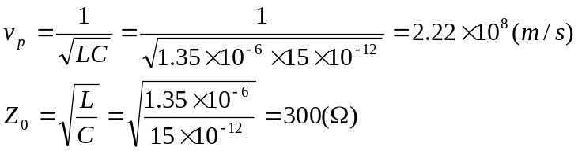

- 15 points. A load of 30-j75 (Ω) is connected to a 75 Ω lossless line. Calculate Γ_{L} and Γ_{in} if the line is 0.15λ long. Find SWR.

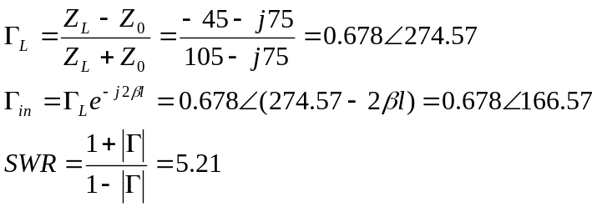

- 10 points. A lossless line terminates in 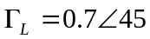. Calculate the distance from the load to the first current min when λ=20cm. Is there a maximum between the load and the minimum?
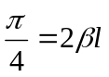→ l=1.25cm. There is no max between the load and the min.

- 15 points. A 12V (rms), 50 Ω generator connects a pair of 50 Ω lines terminated with 100 Ω resistors. One is λ/4 long and the other is λ/2 long. Find the power dissipated on the two resistors.

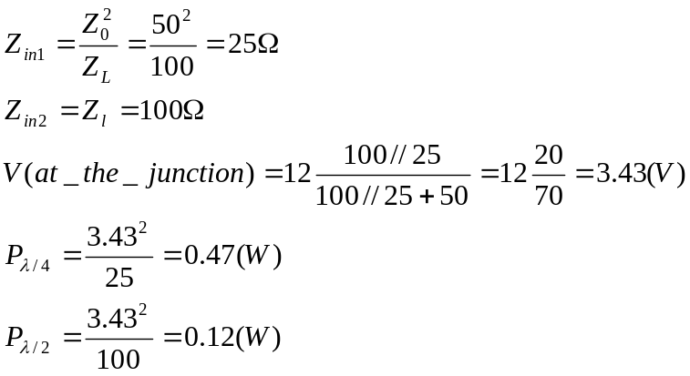
- 10 points. 75 Ω T. Line is terminated with a load 90-j30 (Ω). Use the Smith Chart to calculate SWR and Γ_{L.}
SWR=1.5, 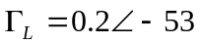
- 15 points. (Use Smith Chart) A 50 Ω line is terminated by a 75 Ω resistor. The input terminals are connected to the output terminals of a 30 Ω line. Both lines are 0.12 λ long.
  - Find Z_{in} and Γ_{in} at the input of the 30 Ω line
  - SWR values on both lines

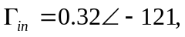 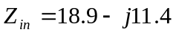 (Ω), SWR=1.5 on 50 Ω line. SWR=1.9 on 30 Ω line.

- 25 points. Use Smith Chart. Find Zin and Yin
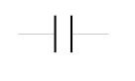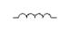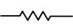
100 Ω
j60 Ω
Z0=50Ω, 0.15λ
-j150 Ω
j100 Ω
Z0=50Ω, 0.12λ
Z_{in}
Zin=220-j140, Yin=3.4e-3+j2.2e-3

